

Best-X-DC With Tim-X
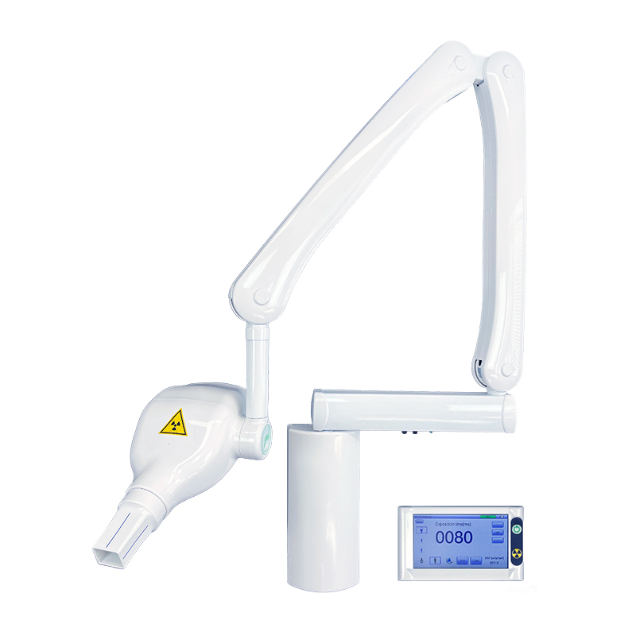

CODE 8100M

The new BEST-X-DC with Tim-X, includes the palmtop TIM -X for a total remote control of all exposure parameters, allowing for a more compact and straightforward installation and operation.
The exclusive market leading 0.3 mm focal spot tube, grants a more detailed X-Ray image with any type of film, sensors and phosphor plates, as well as reducing to the minimum both exposure time and emitted X-ray dose.
It is lightweight and compact, its tube head (only 3.5 kg) allows for easy maneuverability, with immediate, precise and vibration-free positioning.
TIM-X is a state-of-the-art wireless radio-frequency palmtop which allows full control of the X-Ray unit in total safety, ensuring ease of handling.
Remote management of kilovolt [kV], milliamperes [mA], and exposure time [ms], makes the Best X-DC TIM-X a unique device of its kind.
Exposure times are pre-programmed (as per R10 scale) and these may be further customized to suit specific radiographic requirements. The constant DC generated X-Ray output, significantly reduces patient dose. Further operator and patient safety, is provided by the system’s exclusive thermos witch, that stops X-Ray exposure emission, in the unlikely event of failure of the exposure timer.
Technical Data | BEST-X-DC With Tim-X
Classification | Class II Electro-medical Apparatus with type-B part applied
Head | Constant potential radiographic managed by microprocessor
Rated electrical power | 0,800 [kW]
High frequency technology | 100 [kHz]
Focal spot | 0,3 mm (IEC 336)
Absorption | 6 [A]
Tube | OX/70-3
Ø of long cone at the end of spacer | < 6 [cm]
Total filtration | 2 [mm] Al eq.
Selectable anodic current | 4 – 6,5 [mA]
Selectable voltage to x-ray tube | 60 – 70 [kV]
Dispersed radiation | ≤ 0,25 [mGy/h] at 1 meter from focus
Exposure time | 20 ÷ 1000 [ms] scale R10
Intermittent operation Power supply | 230 [V] ± 10%
Intermittent operation | 1 [s] exposure 30 [s] reset max
Distance | F.F.D. 20 [cm]
DAP [mGy*cm²] | For each exposure the DAP value is indicated
Deadman logic control | Wireless

Conformity X-Ray units are manufactured according to Directive 93/42/EEC

